# The Four Functions and Their Archetypes

The fundamentals of our approach to studying mythology are based upon Joseph Campbell’s writings, as well as upon statements made in conversation with Bill Moyers in *The* *Power of Myth* video series, first broadcast in 1988. Understanding of the heroic principle is also based in part upon the work of Christopher Vogler in *The Writer's Journey: Mythic Structure for Writers*, 3rd Edition[1],and others (see “The Pedagogical Function And The Heroic”, and the bibliography). Campbell references four main functions of mythology as a cultural/societal phenomenon:

1. **The Mystical Function**: “Opening the world to the dimension of mystery … [realizing] the mystery that underlies all forms.”[2]
2. **The Cosmological Function**: “Seeing [the totality of experience] as manifest through all things … the universe becomes (as it were) a holy picture, [so that] you are always addressed to the transcendent mystery”.[3]
3. **The Sociological Function**: ”… validating or maintaining a certain society; ethical laws, the laws of life in the society … the values of [a] particular society.”[4]
4. **The Pedagogical Function**: “How to live a human lifetime under any circumstances.”[5]

We can view these functions as progressing from the general and abstract (**The Mystical Function**) to the specific and concrete (**The Pedagogical Function**), and thus approach *all* of them through the lens of how they assist the individual toward self-actualization via the path of understanding the relationships of *self-to-self* (Pedagogical Function), *self-to-society* (Sociological Function), *self-to-universe* (Cosmological Function), and *self-to-spirit* (Mystical Function). Through the mechanism of exploring one’s own inner relationship with the various levels of human experience in the context of the fundamental fabric of existence, the value of mythology is emphasized by focusing one’s awareness toward the interconnectedness of *all* life’s experiences.

It is also useful to associate these four primary functions of mythology with specific archetypes that “embody” the essence of the functions.

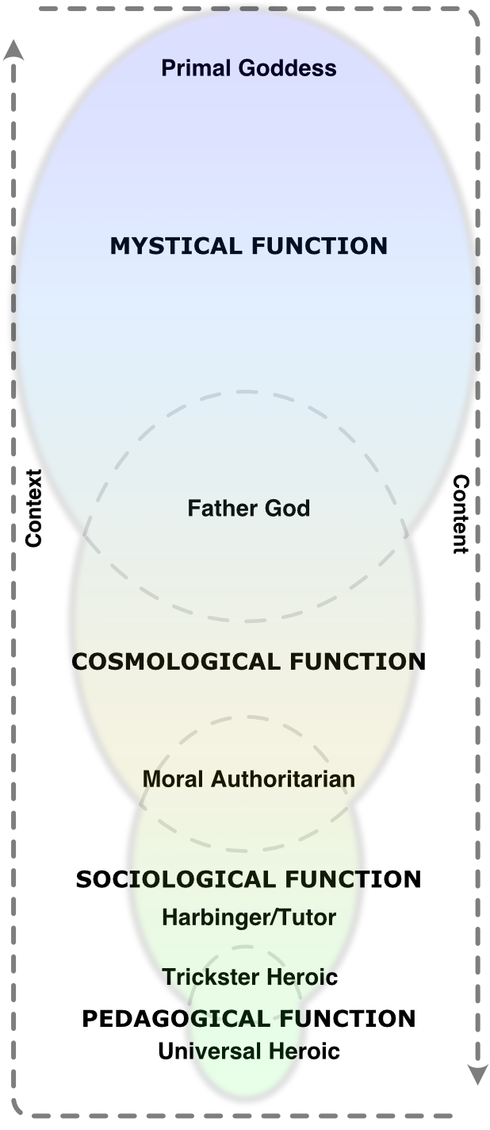

**Mythic Structure Diagram**

## The Archetypes Of The Functions

A dictionary defines “archetype” as:

1. The original pattern or model from which all things of the same kind are copied or on which they are based; a model or first form; *prototype*.
2. (In Jungian psychology), a *collectively* inherited unconscious idea, pattern of thought, image, etc., *universally* present in *individual psyches*. [emphasis added]

When Campbell uses the term “archetype”, he means both of these (much of Campbell’s work was an adaptation of Jung’s prior efforts). Both Jung and Campbell recognized a potentially infinite register of archetypes; here, we are primarily concerned with four:

1. The Primal Goddess
2. The Father God (as Usurping Creator and as Moral Authoritarian)
3. The Trickster (as Harbinger/Tutor and as Trickster Heroic)
4. The Heroic

(The archetype of the Victim/Damsel makes an appearance as well, in connection with the disempowered and demoted Goddess, and the archetype of the Villain is also referenced, as one of the expressions of the Trickster.)

Note that this approach uses “heroic” rather than “hero”, because the latter is gender-specific to the binary male in English. Also, “hero” can be used/interpreted as a limiting label when applied to a person (more on this later, in another context).

Each of the Four Functions, then, is in some sense “expressed through”, “embodied in”, or “personified by” an archetype (the Father God and the Trickster are each associated with aspects of two functions via two of their incarnations, (details below).

1. Christopher Vogler, *The Writer's Journey: Mythic Structure for Writers*, 3rd ed. (Studio City, CA: Michael Wiese Productions, 2007).
2. Joseph Campbell, "The Message of The Myth," interview by Bill Moyers, *Joseph Campbell and The Power of Myth*, produced by Joan Konner and Alvin H. Perlmutter, aired 1988 (first broadcast 1988), on Athena.
3. Joseph Campbell, "The Message of The Myth," interview by Bill Moyers, *Joseph Campbell and The Power of Myth*, produced by Joan Konner and Alvin H. Perlmutter, aired 1988 (first broadcast 1988), on Athena.
4. Joseph Campbell, "The Message of The Myth," interview by Bill Moyers, *Joseph Campbell and The Power of Myth*, produced by Joan Konner and Alvin H. Perlmutter, aired 1988 (first broadcast 1988), on Athena.
5. Joseph Campbell, "The Message of The Myth," interview by Bill Moyers, *Joseph Campbell and The Power of Myth*, produced by Joan Konner and Alvin H. Perlmutter, aired 1988 (first broadcast 1988), on Athena.